**Jacob Alspaw**

**jaa134**

**HW2**

**2/19/2015**

1. This is illogical. Because f(n) = O(g(n)), then the function f(n)’s upper bound is g(n). And because t(n) = O(g(n)), the function t(n)’s upper bound is g(n). The totality of information we have tells us the upper bounds of functions f(n) and g(n). This little of information cannot be used to denote f(n) = Ω(t(n)), where f(n)’s lower bound is t(n). There is no logical connection between functions f(n) and t(n) to examine if one function remains larger, at all times, than the other.
2. 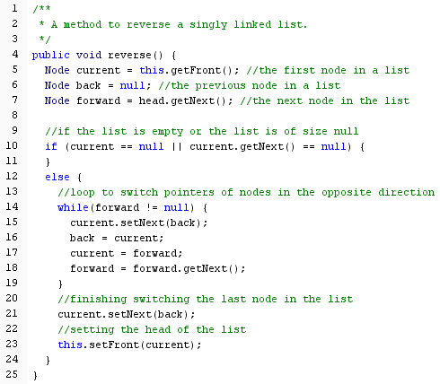

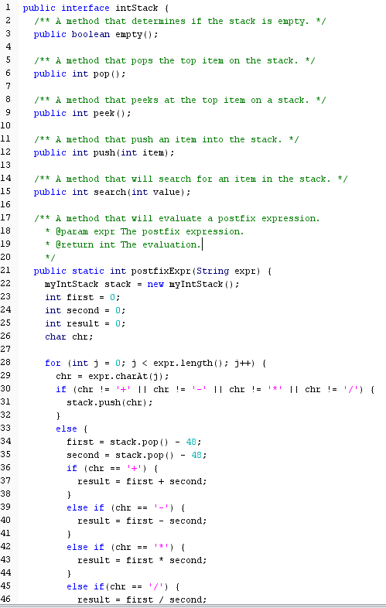3)

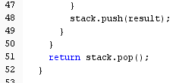

1. A) 2h+1 - 1

B) 2h

C) 2h+1 - 1 – 2h = 2h - 1

D) n + 1 = 2h+1 🡺 log2(n+1) -1 = h

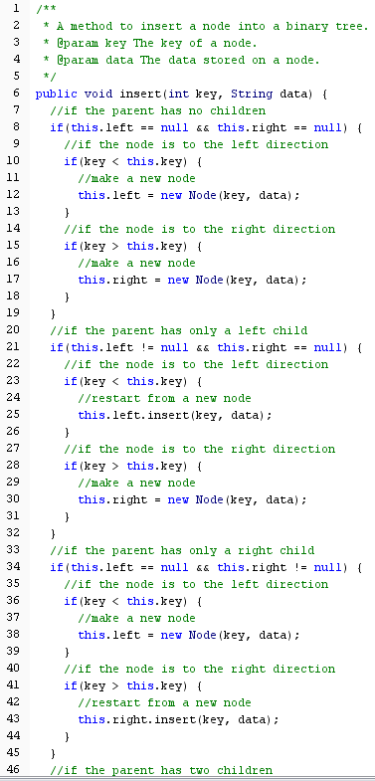



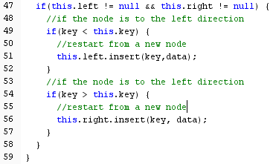

6) After inserting the sequence in order.

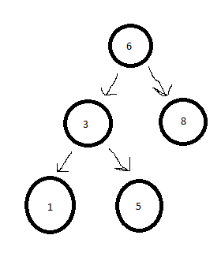

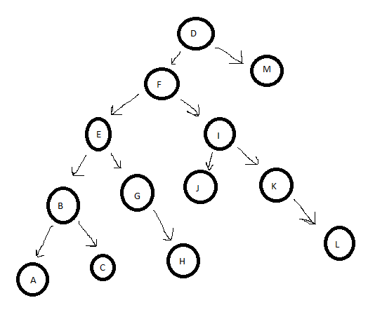

7a) After deleting “x”

7b) After deleting “E”

